Infrastructural Facilities in Jalpaiguri Govt. Engg. College

Land Details of Jalpaiguri Government Engineering College
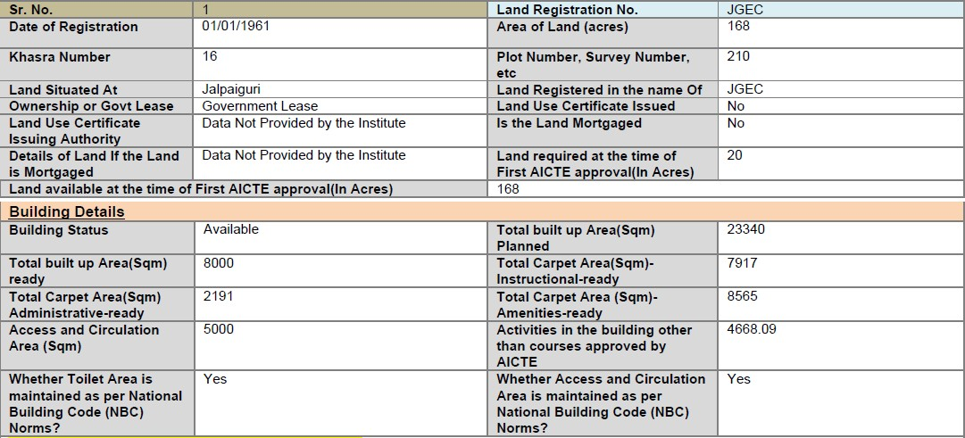
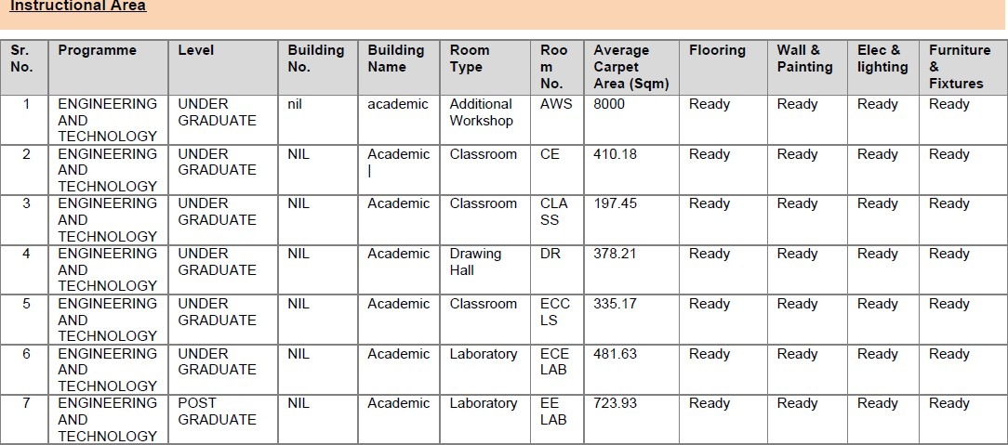

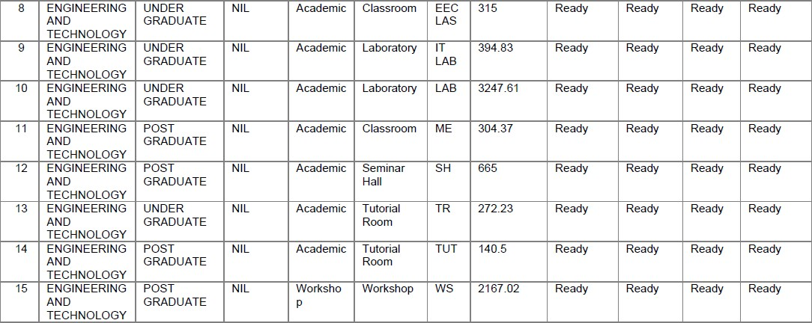
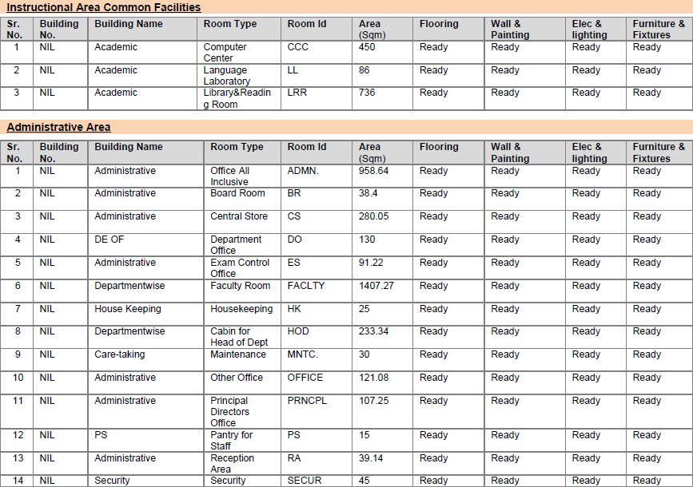

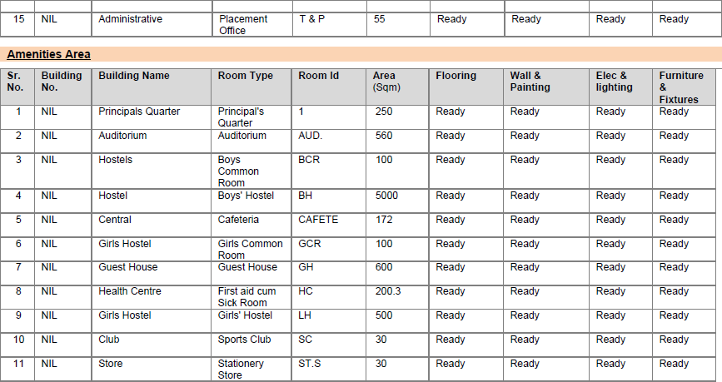

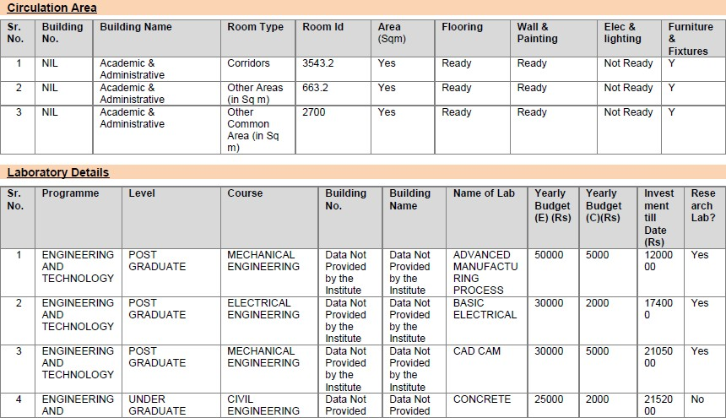

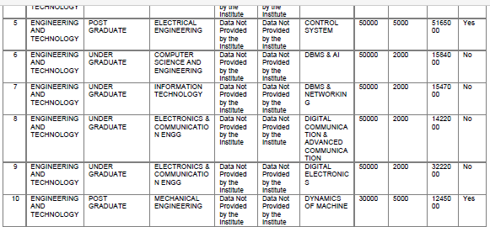

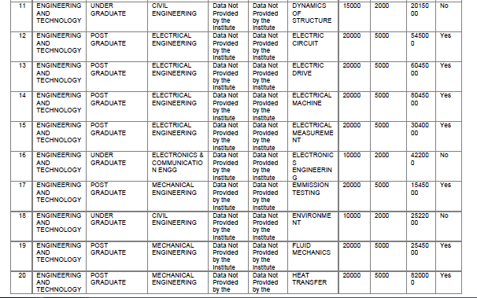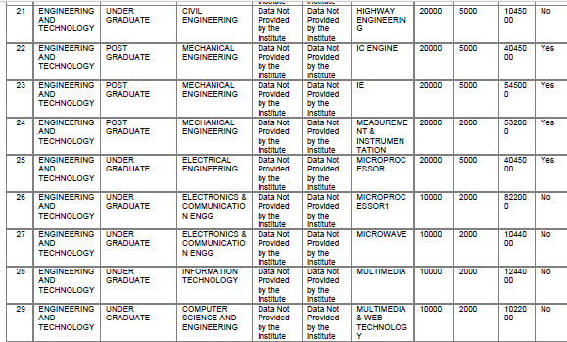

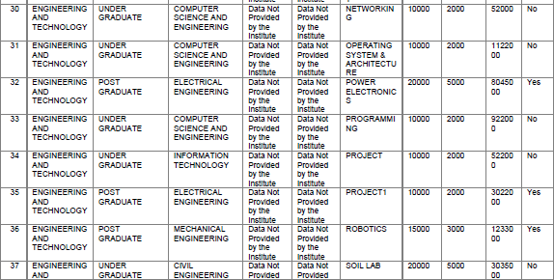
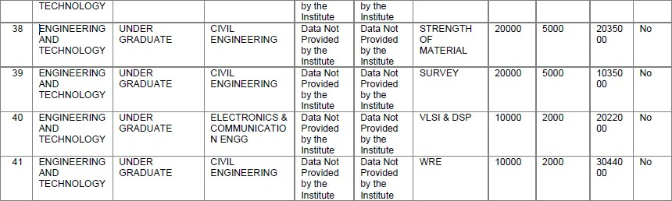
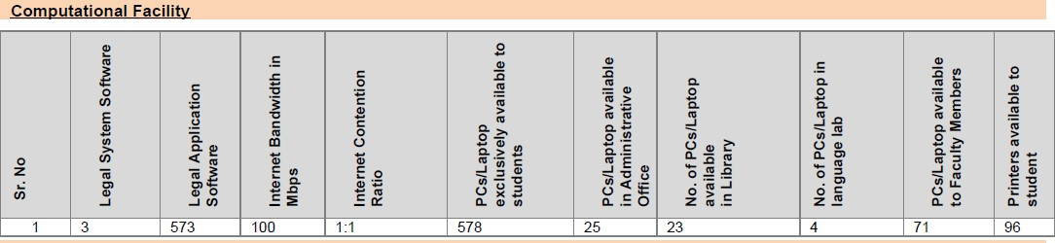

- Hostel Facilities

Sl.  No. | Hostel type | Hostel accommodation | Room area in sq. m | Name of Building | Electric Supply | Back up Electric  supply
1. | Boys | 130 | 1500 | P.C. Roy Hall | Yes | Yes
2. | Boys | 130 | 1500 | J.C.Bose Hall
3. | Boys | 175 | 1950 | S.N.Bose Hall
4. | Boys | 130 | 1500 | N.C.Bose Hall
5. | Girls | 120 | 1350 | NIL

- Information of Infrastructure and Other Resources Available

Sl.  No. | Type of Rooms | Number of Rooms | Size (in sq. m)/ capacity of each room
1. | Class Rooms | 28 | 1529 sq. m
2. | Tutorial rooms | 8 | 1529 sq. m
3. | Laboratories | 45 | 4849 sq. m
4. | Drawing Halls | 3 | 378 sq. m
5. | Computer Centres | 3 | 450
6. | Central Examination Facility | 1 | 2000sq ft.

- Library

Working hours from to | Current Annual Budget Rs | Total library area in sq. m | Library networking | Reprographic facility | No. of multimedia | Reading room seating capacity | Bar code of RF Tab | Library management
10.30a.m. to 5.00p.m | 5,000,000 | 736 | Yes | Yes | 25 | 160 | Yes | Yes
- Number of Library books/ Titles/ Journals available (program-wise)

Name of program | Number of titles | Number of Volumes | Number of journals
 |  |  | Published in  India | Published in  Abroad
Engineering and  Technology | 17916 | 61508 | 46 | 3192
- List of online National/ International Journals subscribed
  - ASCE,
  - ASME,
  - IEL,
  - SPRINGERLINK,
  - MCGRAW HILL,
  - ASTM
- E- Library facilities
Type | Available
e-Books Volumes | 113
e-Books Titles | 476
Library Management Software | 1

Laboratory and Workshop

List of Major Equipment/Facilities in EE department

List of equipments (Cost more than 50,000/-)

Sr. No. | Equipment Name (Costing more than Rs.1 lakh only) | Category* (A/B/C/D) | Date of Purchase | Commissioned? (Yes/No) |  | Stock Register No. | No. of Instructors trained by the supplier on the use/operation of the equipment | No. of Persons  who have used the equipment since installation | Provision of in-house Maintenance |  |  | Availability of adequate quantity of Consumables | Existence of operating manuals (Yes/ No) | Location of the equipment (provide name of the lab/
 |  |  |  |  |  |  |  |  | Yes/ No | If No, whether Annual Maintenan ce Contract is given
 |  |  |  | If yes, | If no, |  |  |  |  | Yes/ No | If No, give
1. | i. Xeo | A | 10.0  4.06 | 08.0  8.06 | N A | 3/1  2 | 04 | 250 |  | NA | NA | Ye s | Ye s | Lab of EE Department
2. | Spec trum | A | 31.0  8.06 | 22.0  5.07 | N A | 12/  80 | 03 | 66 |  | NA | NA | Ye s
3. | Com plete | A | 31.0  8.06 | 28.0  5.07 | N A | 12/  78 | 03 | 66 |  | NA | NA | Ye s
4. | 3ph. AC | A | 31.0  8.06 | 28.0  5.07 | N A | 12/  78 | 03 | 66 |  | NA | NA | Ye s |  | Lab of EE  Dep artm
5. | DSP  base | A | 31.0  8.06 | 28.0  5.07 | N A | 12/  78 | 03 | 66 | Under Warranty | NA | NA | Ye s
6. | Gene rator | A | 31.0  8.06 | 15.0  6.07 | N A | 12/  81 | 02 | 66 |  | NA | NA | Ye s
7. | Tran sfor | A | 31.0  8.06 | 15.0  6.07 | N A | 12/  82 | 02 | 66 |  | NA | NA | Ye s
8. | Set up | A | 31.0  8.06 | 15.0  6.07 | N A | 12/  83 | 02 | 66 |  | NA | NA | Ye s
9. | AC  moto | A | 31.0  8.06 | 15.0  6.07 | N A | 12/  85 | 02 | 66 |  | NA | NA | Ye s
10. | Elect rical | A | 16.0  5.07 | 30.0  1.08 | N A | 12/  93 | 02 | 66 |  | NA | NA | Ye s
11. | Read y to | A | 16.0  5.07 | 30.0  1.08 | N A | 12/  94 | 02 | 66 |  | NA | NA | Ye s
12. | Lab  CBR | A | 31.0  3.05 | 29.0  9.05 | N  A | 1 | 03 | 75 |  | NA | NA | Ye  s | Ye  s | Soil  Lab
13. | Ultra sonic | A | 01.0  9.06 | 02.1  1.06 | N A | 9 | 02 | 60 | Under Warranty | NA | NA | Ye s | Ye s | Con c.
14. | UV  Spec | A | 01.0  9.06 | 16.0  2.07 | N A | 8 | 3 | 65 |  | NA | NA | Ye s | Ye s | Env  .
15. | BOD  Incu | A | 01.0  9.06 | 16.0  2.07 | N A | 25 | 3 | 75 |  | NA | NA | Ye s | Ye s | Env  .
16. | Auto cleav | A | 21.1  2.06 | 16.0  2.07 | N A | 25 | 3 | 70 |  | NA | NA | Ye s | Ye s | Env  .

17. | Refri  gerat | A | 21.1  2.06 | 16.0  2.07 | N  A | 25 | 1 | 65 |  | NA | NA | Ye  s | Ye  s | Env  .
18. | Auto  mati | A | 01.0  9.06 | 30.0  3.07 | N  A | 29 | 1 | 65 |  | NA | NA | Ye  s | Ye  s | WR  E
19. | Auto  mati | A | 01.0  9.06 | 30.0  3.07 | N  A | 28 | 1 | 65 |  | NA | NA | Ye  s | Ye  s | WR  E
20. | Mec  hani | A | 01.0  9.06 | 18.0  6.07 | N  A | 36 | 2 | 65 |  | NA | NA | Ye  s | Ye  s | Env  .
21. | Disti  lled | A | 22.1  2.06 | 05.0  6.07 | N  A | 35 | 3 | 65 |  |  | NA | Ye  s | Ye  s | Env  .
22. | Digit  al | A | 01.0  9.06 | 34 | N  A | 34 | 3 | 65 |  | NA | NA | Ye  s | Ye  s | Env  .
23. | Smo  ke | A | 28.0  3.05 | Yes | N  A | 3 | 2 | 60 |  | NA | NA | Ye  s | Ye  s | I. C.  Eng
24. | Mult  i Gas | A | 09.0  3.07 | Yes | N  A | 44 | 2 | 60 |  | NA | NA | Ye  s | Ye  s | I. C.  Eng
25. | Basi  c | A | 04.1  0.05 | Yes | N  A | 14(  01) | 3 | 60 |  | NA | NA | Ye  s | Ye  s | Hyd  rauli
26. | Bern  oulli | A | 04.1  0.05 | Yes | N  A | 14(  02) | 4 | 60 |  | NA | NA | Ye  s | Ye  s | Hyd  rauli
27. | Varia  ble Com | A | 05.0  3.07 | Yes | N  A | 46 | 3 | 60 |  | NA | NA | Ye  s | Ye  s | I. C.  Eng
28. | CVS  Echo | A | 30.0  6.07 | 06.0  9.07 | N  A | 37 | 3 | 60 |  | NA | NA | Ye  s | Ye  s | WR  E
29. | Digit  al | A | 05.0  3.07 | Yes | N  A | 47 | 3 | 60 |  | NA | NA | Ye  s | Ye  s | I. C.  Eng
30. | Lase  r | A | 05.0  3.07 | Yes | N  A | 62 | 3 | 60 |  | NA | NA | Ye  s | Ye  s | I. C.  Eng
31. | Fran cis | A | 09.0  3.07 | Yes | N A | 60 | 3 | 60 |  | NA | NA | Ye s | Ye s | Flui d
32. | Serie  s | B | 04.1  0.05 | Yes | N  A | 14  (03 | 2 | 60 | Under Warranty | NA | NA | Ye  s | Ye  s | Hyd  rauli
33. | Vibs  cann | B | 09.0  3.07 | Yes | N  A | 49 | 2 | 60 |  | NA | NA | Ye  s | Ye  s | Flui  d
34. | Kapl  an | B | 09.0  3.07 | Yes | N  A | 61 | 3 | 60 |  | NA | NA | Ye  s | Ye  s | Flui  ds
35. | Micr  o | B | 21.1  2.06 | 01.0  2.07 | N  A | 24 | 2 | 60 |  | NA | NA | Ye  s | Ye  s | Env  .
36. | Total  Stati | B | 01.0  9.06 | 23.1  0.06 | N  A | 7 | 2 | 60 |  | NA | NA | Ye  s | Ye  s | HO  D
37. | Stati  c | B | 01.0  9.06 | 23.0  3.07 | N  A | 31 | 2 | 60 |  | NA | NA | Ye  s | Ye  s | Soil  Lab
38. | MIG  Wel | A | 20.1  2.06 | 2203  .07 | N  A | 1 | 7 | 60 | Under Warranty | NA | NA | NO | Ye  s | Tin  y
39. | TIG  Wel | A | 20.1  2.06 | 22.0  3.07 | N A | 2 | 7 | 60 |  | NA | NA | NO | Ye s | Tin y

40. | Hydr  aulic | A | 20.1  2.06 | 27.0  4.07 | N  A | 3 | 7 | 60 |  | NA | NA | NO | Ye  s | Fou  ndry
41. | BHN  Testi | A | 20.1  2.06 | 27.0  4.07 | N  A | 4 | 7 | 60 |  | NA | NA | NO | Ye  s | Tin  y
42. | Mot  orize | A | 20.1  2.06 | 29.0  4.07 | N  A | 6 | 7 | 60 |  | NA | NA | NO | Ye  s | Tin  y
43. | Sea  m | A | 24.0  5.07 | 05.1  0.07 | N  A | 9 | 7 | 60 |  | NA | NA | NO | Ye  s | Tin  y
44. | Arc  Wel | A | 24.0  5.07 | 23.0  8.07 | N  A | 15 | 7 | 60 |  | NA | NA | NO | Ye  s | Tin  y
45. | Rob  otic | C | 16.1  2.05 | Yes | N  A |  | 7 | 60 |  | NA | NA | NO | Ye  s | Lab  of
46. | Ato  mic | C | 01.0  9.06 | 16.1  2.07 | N  A | 25 | 2 | 60 | Under Warranty | NA | NA | NO | Ye  s | Env  .
47. | Com  puteri zed | C | 05.0  3.07 | Yes | N  A |  | 2 | 80 |  | NA | NA | NO | Ye  s | Lab  of
48. | Serv  er, | D | 28.0  6.07 | Yes | N  A |  | 10 | 1400 |  | NA | NA | NO | Ye  s | CC  C

* A: Rs. ≥ 1 lakhs & <Rs.5 lakhs B: Rs. ≥ 5 lakhs &<Rs.10 lakhs
C: Rs. ≥ 10 lakhs &<Rs.20 lakhs D: Rs. ≥ 20 lakhs

Equipment Utilization for the equipments covered under 6.1A (Category C & D only i.e. Costing Rs. ≥ 10 lakhs)
Sr. No. | Equipment Name (Costing ≥ Rs.10 lakhs only) | Name of the courses/ disciplines in which equipment is utilized for | Existence of log book (Yes/No) | Hours used in Jan 2009 (according to log book) | Utilization in Hours per month = from 9:15a.m. to 5:00p.m. on all working  days
 |  |  |  |  | By students (UG and PG) according to the official | Research (PhD) | Continuing Education Classes | Networking activities |  |  | Services to community activities  (unorganized/organized | Sponsored Projects and Consultancy Services | Total hours
 |  |  |  |  |  |  |  | Programme institutions | Non programme academic institutions and R&D | Industry
4  5 | Robotic Training System with Accessori es | B.  Tech | Ye s | 30  hou rs | UG | NA | NA | NA | NA | N A | NA | NA | 30 hours
4  6 | Atomic Absorptio n  Spectroph o-tometer | B.  Tech | Ye s | 30  hou rs | UG | NA | NA | NA | NA | N A | NA | NA | 30 hours

4  7 | Computeri  zed Multi Cylinder Petrol Engine Test set up with Eddy current Dynamom  eter | B.  Tech | Ye  s | 30  hou rs | UG | NA | NA | NA | NA | N  A | NA | NA | 30 hours
4  8 | Server,  Storage, PCs and LCD  Projector | B.  Tech | Ye  s | 720  hou rs | UG | NA | NA | NA | Yes | N  A | NA | Yes | 720  hours
Note : Sr. No. of the equipment in this sheet must also be same as of previous one. (include Category C & D only
i.e. Rs. ≥ 10 lakhs)

List of Major Equipment/Facilities in ECE department

Basic Electronics

List of Experiments
  - V/I Characteristics of Zener Diode
  - V/I Characteristics of PN junction diode
  - V/I Characteristics of JFET
  - Familiarization of basic electronic components
  - V/I Characteristics of BJT in common emitter, common collector and common base mode
  - Introduction to logic families List of Component/ Device available
- Zener Diode kit
- PN junction Diode Trainer Kit
- FET and BJT Trainer kit
- Logic families Trainer kit
- CRO
- Function Generator
- DMM
- Power supply

- DSP Lab
List of Experimental setup
  - Linear and circular convolution
  - DFT and IDFT using MATLAB
  - Butterworth Filter design and its characterization
  - Chebyshev Filter design and its characterization
  - FIR filter design using different windowing techniques
  - FIR filter design using frequency sampling method
  - FIR filter design using Equiripple method
  - Adaptive filter design using LMS method Available Equipment

- Computer with MATLAB facility
- DSP kit

- Analog communication List of Experiment
  - Study of Modulation Index (AM) from carrier and modulating signal.
  - Study of Over, Under and Critical Modulation.
  - Study of Side Bands of AM using Spectrum Analyzer.
  - Study of Demodulation using Envelope Detector.
  - Study of Sensitivity, Selectivity of Super Heterodyne Receiver. vi)Calculation of Bandwidth and Modulation Index of FM.
vii) Study of Demodulation of FM using Foster SeleyDetectior or PLL.
List of Components
- AM Transmitter Kit ( NO. 3)
- AM Receiver Kit ( NO. 3)
- FM Transmitter&Receiver Kit ( NO. 4)
- CRO
- DSO
- Spectrum Analyzer
- AM Receiver Kit ( NO. 3)

- Digital Communication List of Experiments
  - Study of PCM
  - Study of PAM, PPM, PWM
  - Study Delta and Adaptive Delta Modulation
  - Study of ASK
  - Study of FSK
  - Study of PSK vii)Study of Line Coding viii)Study of TDM, FDM

List of Components/Devices

- Trainer kit for PCM
- Trainer kit of PAM, PPM, PWM
- Trainer kit ofDelta and Adaptive Delta Modulator
- Trainer Kit for ASK, FSK and PSK
- Trainer Kit for TDM, FDM
- CRO

- Microprocessor & Microcontroller List of Experiment
  - Addition
  - Subtraction
  - Logical operations
  - Data Transfer
  - Sorting
  - Implementation of Traffic signaling mechanism using 8085
  - Arrangement from list of data inputs

List of Components:

- DYNA-85 Microprocessor Kit for 8085 (20) + SMPS(20)
- Trainer kit for peripheral device 8255 and 8279 (10)
- 8051 Trainer Kit (2)

- Antenna Lab
List of Experiments
  - Radiation Pattern of dipole antenna.
  - Radiation Pattern of a folded-dipole antenna.
  - Radiation pattern of a 3-element Yagi-Uda Antenna.
  - Beam width, gain and radiation pattern of a 3-element, 5-element and 7-element. Yagi-Uda antenna - Comparative study.
  - Radiation pattern, Gain, Directivity of a Pyramidal Horn Antenna. Component/Device:
- Dipole Antenna
- Yagi-Uda Antenna Setup
- Horn Antenna
- Folded Dipole

- Microwave Lab List of Experiments
  - Introduction to various instruments used in Microwave lab
  - Characteristics of Reflex Klystron
  - IV characteristics of GUNN Diode
  - Voltage versus power plot of GUNN Diode
  - Frequency and wavelength measurement using GUNN Diode
  - Frequency and wavelength measurement using Reflex Klystron
  - Directivity, coupling Factor etc measurement using directional coupler and Magic Tee List of Components:
- Experimental setup for Reflex Klystron
- Experimental Setup for GUNN Diode
- VSWR meter
- CRO
- Directional coupler
- Magic Tee, E-Plane Tee, H-Plane Tee
- Horn Antenna

- Analog Electronics Lab List of Experiments
  - Diode Clipper circuit in biased and unbiased condition
  - Diode Clamper circuit forward and reverse bias mode
  - Adder circuit using OPAMP
  - Inverting amplifier using OPAMP
  - Non-Inverting Amplifier using OPAMP
  - Integrator and Differentiator using OPAMP List of Components/Devices
- CRO

- Function generator
- Digital Multimeter
- OPAMP
- Resistors, Capacitors and other ICs
- Breadboard
- Analog and Digital trainer Kit with power supply.

- FPGA lab
List of Experiment
  - Implementation of basic logic gates with VHDL on FPGA using different design styles.
  - Implementation of Multiplexers, Priority Encoder, decoder, counters etc. with VHDL on FPGA using different design styles.
  - Design and implementation of 16-bit ALU with VHDL on FPGA and verification by writing a test bench.
  - Generation of Filter co-efficient of a LPF using Simulink FDA tool.
  - Testing of the LPF by using the hardware-in-the loop configuration.
  - Design and implementation of a real time user defined Traffic Light Controller using FSM method on an FPGA.

Component/Device:
- Xilinx Spartan-3E Kit (20)
- Computer with ISE software facility

- Control System Lab List of Experiment
  - Step, ramp and impulse response
  - Identification of damping in second order
  - Time domain analysis
  - Stability analysis using routh-hurwitz method
  - Frequency response analysis using bode plot
  - Frequency response analysis using polar plot Component/Device
i) Computer with MATLAB facility

- Signal and System Lab List of experiments
  - Basic mathematical operation using MATLAB
  - Generation of continuous and discrete signal
  - Convolution of two signals
  - Folding and shifting operation on a sequence
  - Impulse response of a LTI system
  - Find DFT and DTFT of a given sequence
  - FFT using Radix-2 method Component/Device
i) Computer with MATLAB facility
- Digital Electronics List of Experiment
  - Construction of various logic gates universal gates

  - Binary to gray code conversion using Logic gates
  - BCD to excess-3 conversion using logic gates
  - Construction of full adder circuit using basic gates
  - Construction of full subtractor circuit using basic gates
  - 2-bit comparator circuit using logic gates
  - 4:1 Multiplexer circuit using logic gates
  - Construction of a decoder circuit using basic gates
  - Construction of SR,JK and D-FF and verify the truth table List of components
- Various ICs
- Trainer kit
- Power supply
- DMM

- VLSI Circuit and system Lab List of Experimental setup
  - Output Characteristics and Transfer characteristics of NMOS and PMOS using PSpice
  - Transfer characteristics and transient response of resistive load inverter and CMOS inverter
  - Designing and simulation of NAND, NOR, XOR and XNOR gate in PSpice
  - Design of Full adder using half adder by hierarchical method in PSPICE.
  - Design of full Adder using VHDL
  - Design of 2:4 Decoder using VHDL List of Component
- Computer with ORCAD PSpice Lite(Student Edition)
- Altera Quatrus Software

Computing Facilities

PCs/Laptop exclusively available to students | 587
PCs/Laptop available in Library: | 23
PCs/Laptop available in Administrative Office | 25
PCs/Laptop available to Faculty Members: | 71
Number of PCs/Laptop in language lab: | 01
Internet Bandwidth in Mbps | 1Gbps
Internet Contention ratio | 11
Printers available to student | 96
Number of A1 Size Color Printers | 0
Number of Legal System software | 3
Number of Legal Application software | 573
- Internet Bandwidth- 1Gbps
- Number and configuration of System: 3servers
- Total number of system connected by LAN: 1700
- Total number of system connected by WAN: 1200
- Major software packages available: Linux server etc.

Special purpose facilities available

Sl. No. | Name Of the Committee | Members of Committee
1. | Nature club | Dr. ArindamSaha, Assistant Professor,  Dept. of Physics- In charge
2.. | Institute Research Committee | Dr. Santanu Das, Associate Professor, Dept. Of Electrical Engineering, Chairman  Dr. DipakKoley, Associate Professor, Dept. Of Computer Science & Engineering, Member  Dr. JishanMehedi, Associate Professor, Dept. Of Electronics & Communication Engineering, Member
3. | Smart India Cell | Dr.SwagataMandal, Assistant Professor of Dept. Of Electronics & Communication Engineering  Mr.MirwaizRahaman,Assistant  Professor of Dept. Of Electronics & Communication Engineering
4. | Solar Energy &Weather monitoring Cell | Dr.SoupayanMitra, Associate Professor of Dept. Of Mechanical Engineering-  In-charge
5. | Institute internship committee | Dr. DipakKoley, Head-Dept. Of Computer Science & Engineering, Chairman  Dr. JishanMehedi, Associate Professor, Dept. Of Electronics & Communication Engineering, Member  Dr.NripenMandal, Assistant Professor, Dept. Of Mechanical Engineering, Member  Mr.Aditya Samanta, Assistant Professor, Dept. Of Information Technology, Member
6. | Institute Innovation Cell | Prof. Mr. Subhranta Roy Chowdhury, Associate Professor, Mechanical Engineering,  Dr. Santanu Das, Associate Professor, Dept. Of Electrical Engineering,  Dr. DipakKoley, Head-Dept. Of Computer Science & Engineering, Chairman

  - Social media cell
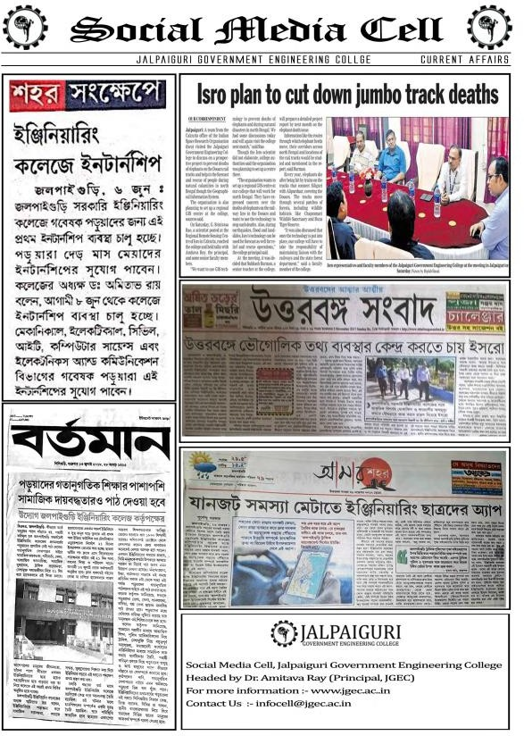
- Games and Sports Facilities
Name of the committee | Members in the committee | Activities
Sports Committee | Mr. Subhranta Roy Chowdhury- Chairman  Mr. SUMAN MONDAL- in charge | Cricket, Football, Volley Ball, Cycle racing

Extra-Curricular Activities:
  - Drama school
  - Tree Plantation
  - Blood donation camp
  - NSS in curriculum
  - Social service in rural areas

Soft Skill Development Facilities:
  - Smart class rooms equipped with projectors and smart screens
  - Upgraded Language laboratory with sufficient number of PCs for students.
  - Practice of Mock Test , Mock Interview Group Discussion on regular basis.

Teaching Learning Process:
  - JGEC follows outcome-based education to develop the requisite knowledge, skills, attitudes and habits of students as well as faculties.

  - Students work on institute projects in different departments. Internship and project-based courses are part of different curricula.

  - Copy of lesson plans is shared with the students during the introductory lecture at the beginning of the semester so that the student is aware of the entire flow of the progress of lessons in each subject and also about the pre- requisites pertaining to that subject.

  - Subject teachers and counselors/mentors conduct counseling sessions to weaker students so that their academic performance can be improved in the future tests/examinations

  - Based on the academic background, intellectual level, soft skill & special skill of students, the lectures are developed accordingly. Institute provides question bank, assignment to students as per the curriculum.

- Curricula and syllabus for each of the programmes as approved by the University
Sl. No. | Name of the Course | Link for Syllabus
1. | Civil Engineering (UG) | http://jgec.ac.in/downloads/CE_UG_syllabus_complete_old.pdf
2. | Electrical Engineering (UG) | http://jgec.ac.in/downloads/EE_UG_syllabus_complete_old.pdf
3. | Mechanical Engineering (UG) | http://jgec.ac.in/downloads/ME_UG_syllabus_complete_old.pdf
4. | Computer Science and Engineering (UG) | http://jgec.ac.in/downloads/CSE_UG_syllabus_complete_old.pdf
5. | Electronics and Communication Engineering  (UG) | http://jgec.ac.in/downloads/ECE_UG_syllabus_complete_old.pdf
6. | Information Technology (UG) | http://jgec.ac.in/downloads/IT_UG_syllabus_complete_old.pdf

Academic Time Table with the name of the Faculty members handling the Course
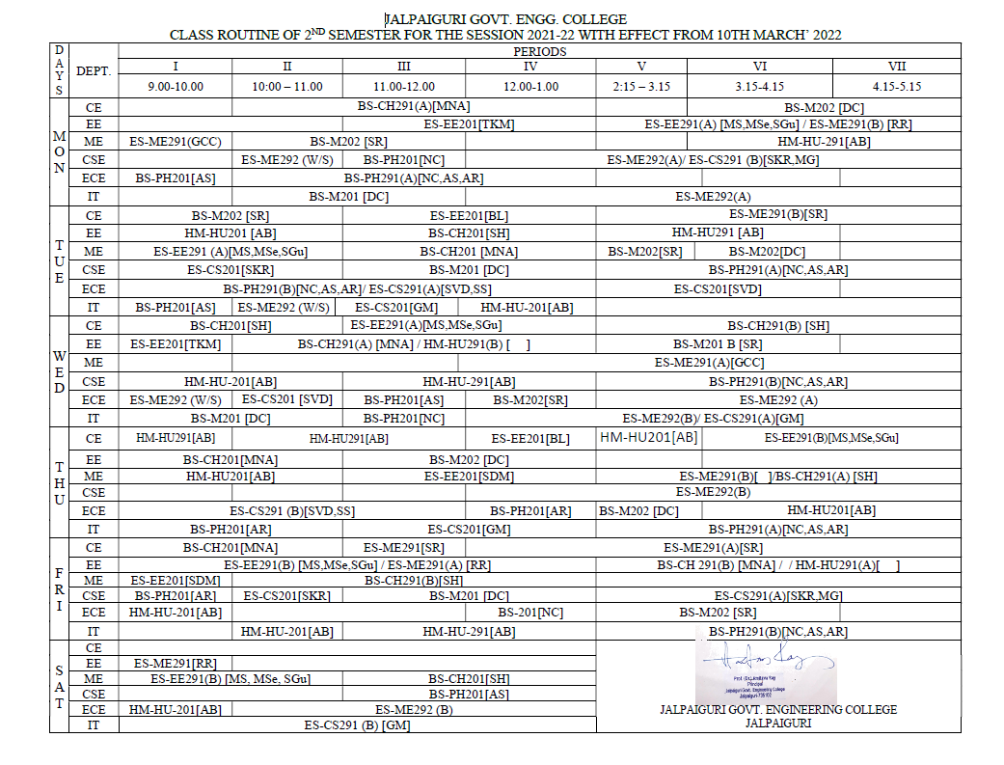

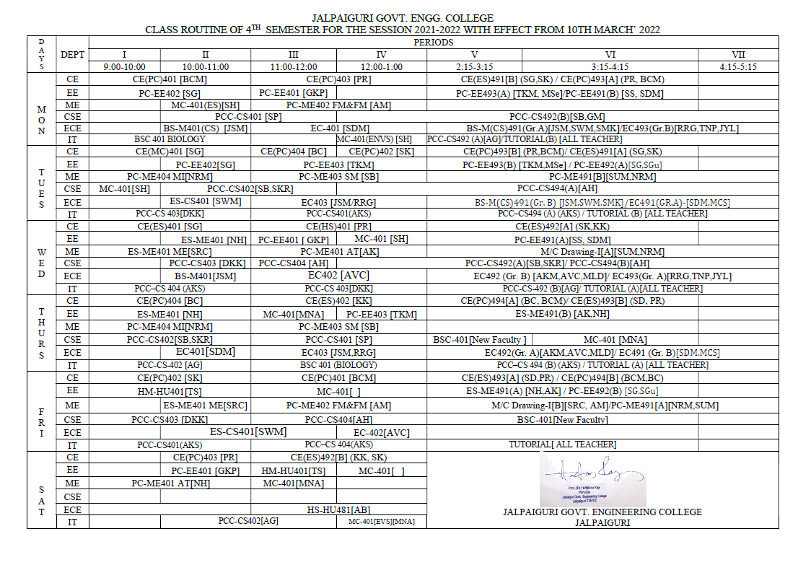

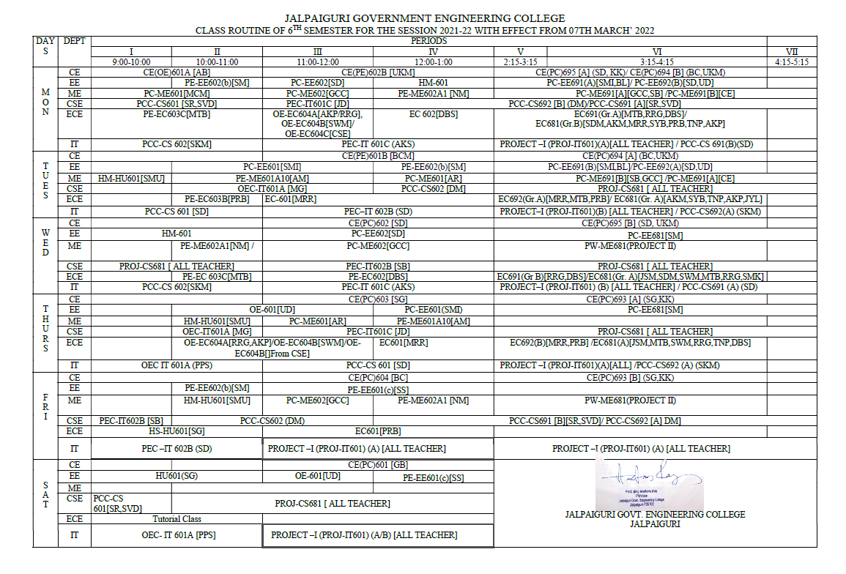

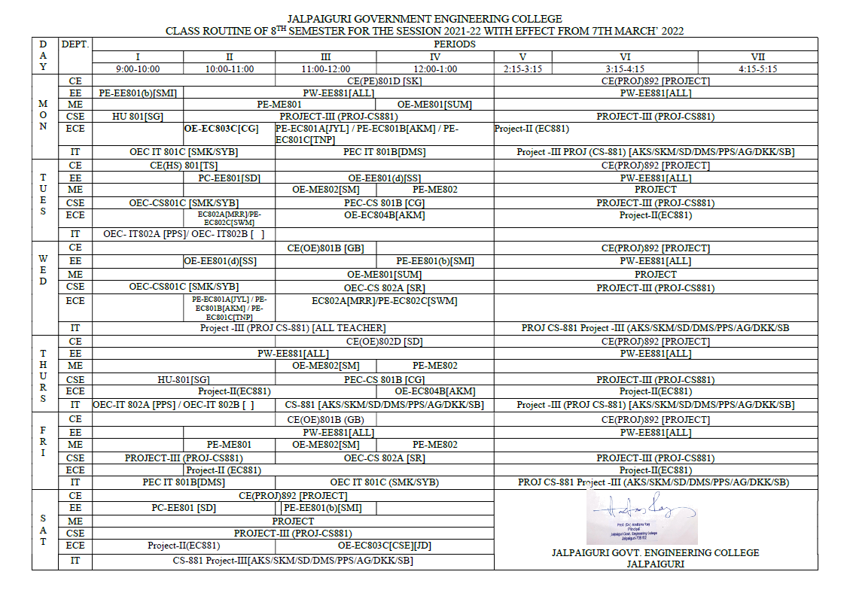

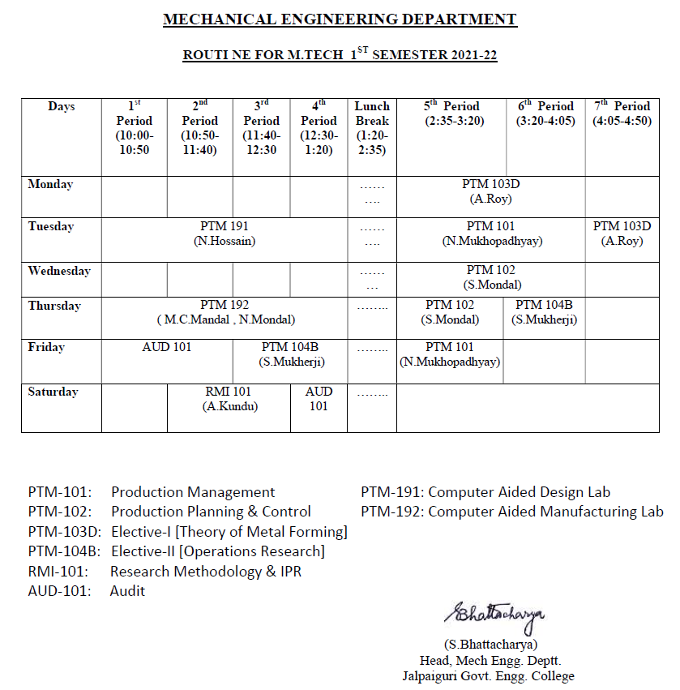
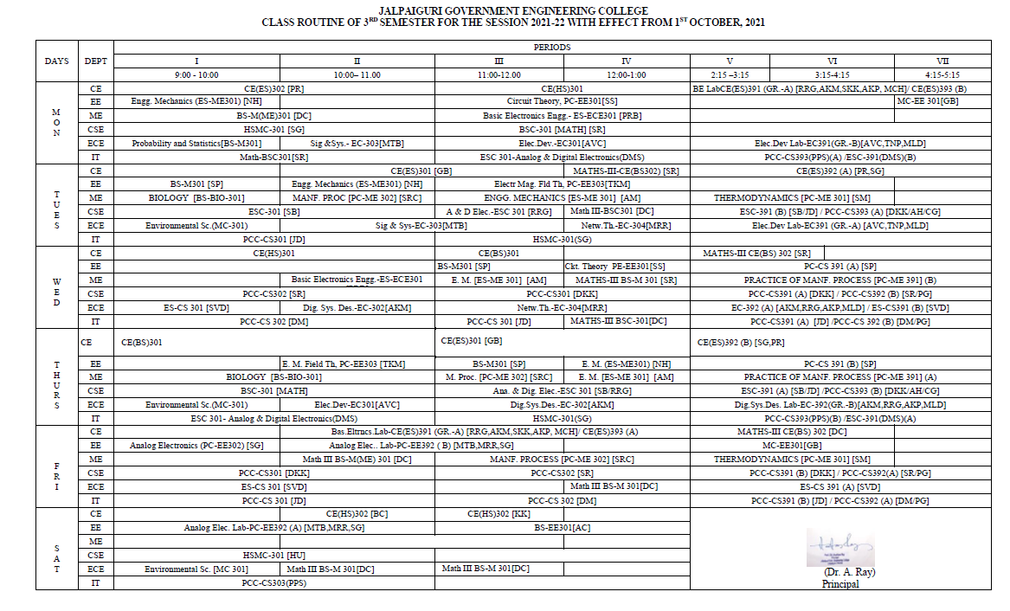

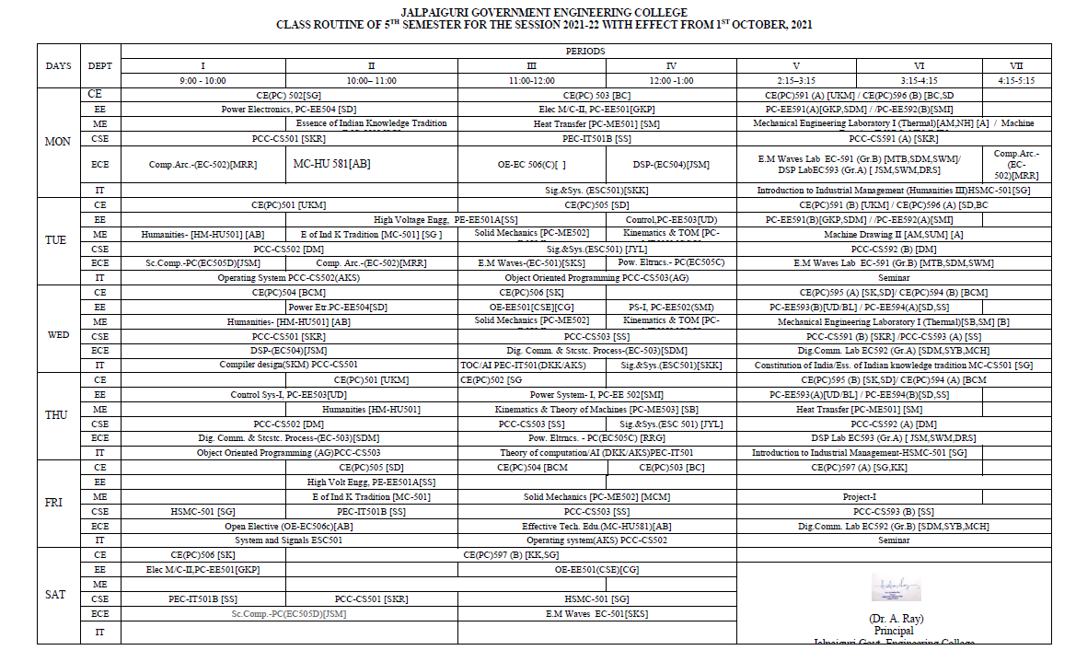

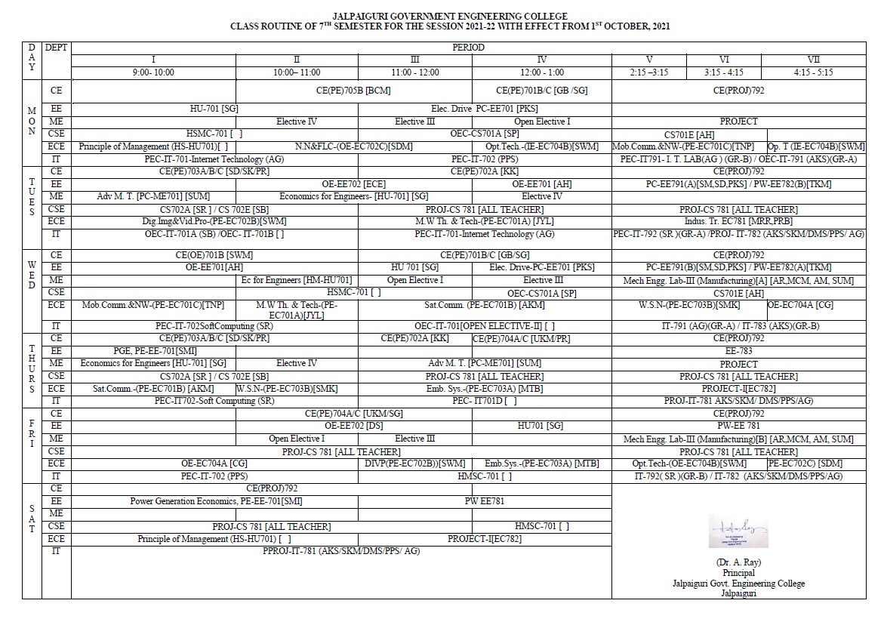

- Academic Calendar of the Institute

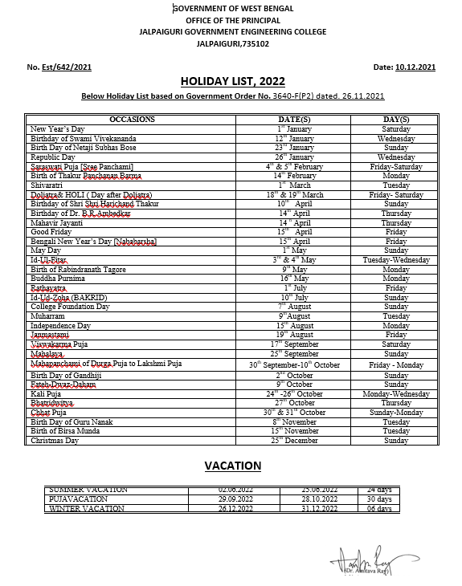
- Teaching Load of each Faculty- As per AICTE norms
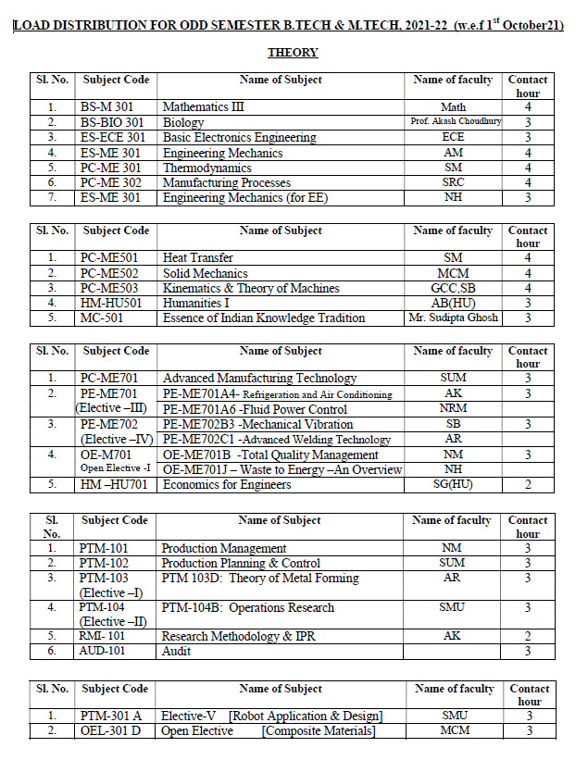
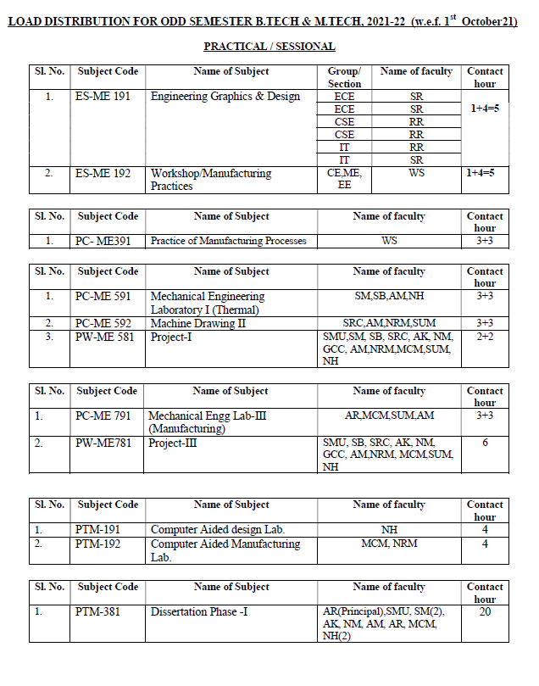
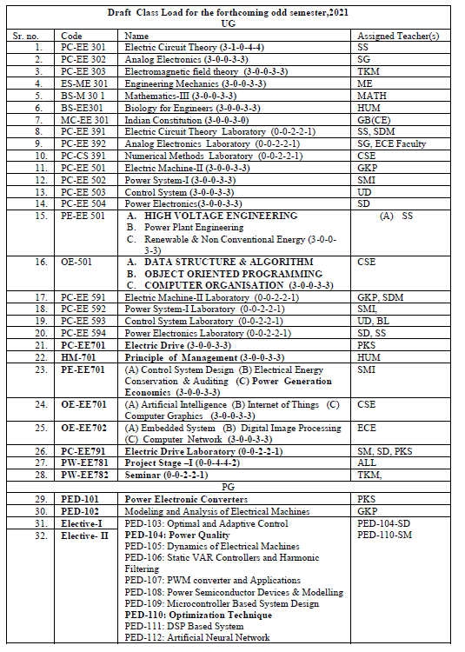

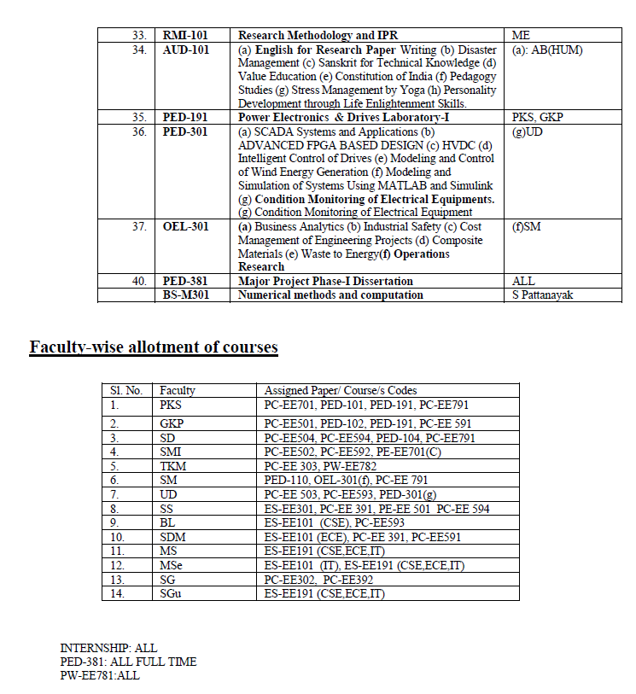

Internal Continuous Evaluation System and place

Type of Continuous Evaluation | Details of Evaluation

Internal Assessment | - Conducting internal examination for theory papers (both centralized and de-centralized basis), rigorous practice of assignments, evaluation based on attendance and class performance of students.  - Evaluation through lab report, viva-voce for practical papers in dedicated laboratories.  - Report submission for sessional papers along with viva-voce and power point presentations.
External Assessment | 1. Centralized Semester examination for both theory and practical  papers

- Student’s assessment of Faculty, System in place

Whether feedback for faculty taken  (Yes/No) | Whether feedback for Institution taken  (Yes/No) | Mode of feedback  (Online/Offline)
Yes | Yes | Offline

Jalpaiguri Government Engineering College STUDENT FEEDBACK FORM

Department Semester/year Academic year, 2018-19, Date:
Use the scale to answer the following questions below and make comments
1-Strongly Disagree, 2-Disagree, 3-Somewhat Agree, 4-Agree, 5-Strongly Agree
Name of faculty:1. 4. 5. |  |  |  | 2.  6. | 3. |  |  | Subject code
A. | Faculty is prepared for each class.
B. | Faculty has completed the whole course.
C. | Faculty communicates the subject matter effectively.
D. | Medium of instruction
E. | Faculty shows respect towards students and encourages class participation.
F. | Faculty arrives on time.
G. | Faculty leaves class on time.
H. | Faculty was available during the specified office hours and for after class consultations.
I. | The assignments and exams covered the  materials presented in the course.
 | PERSONAL FACTORS |  |  |  |  |  |  |  | Write | “yes ” | or | No
J. | I cannot follow the lecture
K. | I do not work hard
L. | I don’t do the homework/or prepare for the course
M. | I do poorly on tests.
N. | I feel that |  | the | exam | is | too | hard.

O. | I have difficulty learning the material
P. | I have difficulty taking tests.
Q. | I do not attend classes regularly
R. | The faculty cannot teach his/her subject matter
s | I am not prepared for course (prerequisites for class).
T | I don’t have time to do the homework.
U | I am unable to attend class on time
V | I have to take care of my family/personal problems
w | I was forced to take admission by my parents
x | I am interested only on placement
Y | I have been taught 10th& 12th in regional language
Z | I never meet my mentor

Comments
Course: 1) How much of the syllabus covered in the class(40%<syllabus<60%, 60%<syllabus<75%,&75%<syllabus<100%, less than 40%)
Faculty: Total class taken:- Your comments:-
Mentor:
Laboratory classes:

- For each Post Graduate Courses give the following:
Α) Title of the Course (EE)
M.TECH. IN ELECTRICAL ENGINEERING (POWER ELECTRONICS AND DRIVES)
Curricula and Syllabi | Visit the  linkhttp://jgec.ac.in/downloads/EE_PG_syllabus_full_2018_final_new.pdf

- Laboratory facilities exclusive to the Post Graduate Course
Sl. No. | Name of the Paper | Room No.
1. | Power Electronics and drives lab & Simulation | PG lAb-1

- Academic Calendar and frame work

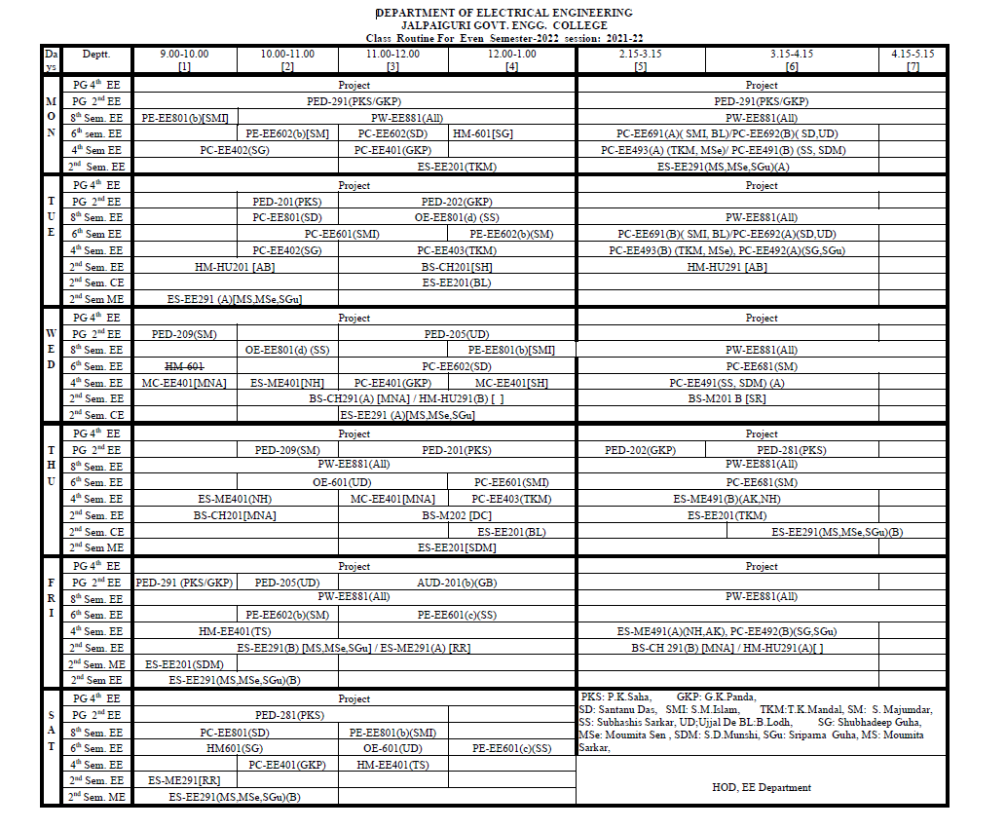
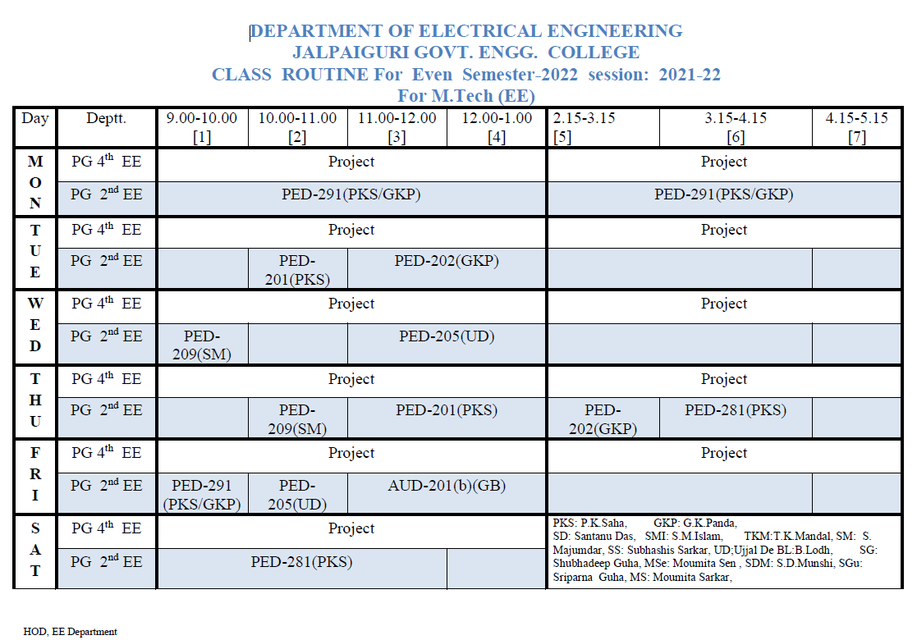

B) Title of the Course (ME):
M.TECH. IN MECHNICAL ENGINEERING (PRODUCTION TECHNOLOGY&MANAGEMENT)

Curricula and Syllabi | Visit the  linkhttp://jgec.ac.in/downloads/ME_PG_syllabus_full_2018_final_new.pdf

- Laboratory facilities exclusive to the Post Graduate Course
Sl. No. | Name of the Paper | Room No.

- Academic Calendar and frame work

Days | 1st Period (10:00-  10:50) | 2nd Period (10:50-  11:40) | 3rd Period (11:40-  12:30) | 4th Period (12:30-  1:20) | Lunch Break (1:20-  2:35) | 5th Period (2:35-3:20) | 6th Period (3:20-  4:05) | 7th Period (4:05-  4:50)
Monday |  |  | PTM203C (NM) | PTM 292 (SMU) | ……… | PTM 292 (SMU)
Tuesday | PTM291 (MCM,SUM) |  |  |  | …….... | PTM202 (SUM)
Wednesday | PTM 281 (SMU,NM) |  |  |  | ……… | PTM204B (SM)
Thursday |  | PTM202 (SUM) | PTM 201 (MCM) |  | ………
Friday |  | PTM201 (MCM) | AUD201B |  | ………
Saturday | PTM204B (SM) |  | PTM203C (NM) |  | ………

List of Research Projects/ Consultancy Works

Sl. No. | Name of Projects carried  out | Funding Agency | Grant Received | Duration | Remarks
1. | Green supply chain performance measurement: A comparative study of manufacturing organizations in West-  Bengal | DST, West Bengal | 14.7 Lakhs | 3 years | Ongoing
2. | Skill and Personality  Development Program | AICTE | 12.36 Lakhs | 3 years | Ongoing
3. | MODROB on  Modernization of Power Electronics & Drives Laboratory of Electrical Engineering Department in Jalpaiguri Government Engineering College | AICTE | 15.52 Lakhs | 3 years | Ongoing
4. | Performance Evaluation of Sand/Stone Column in Clay under Varying Loading and Different Combinations of Configurations | Department of Higher Edu., Science & Technology and Biotechnology, Govt. of West  Bengal | 15.16 Lakhs | 3 Years | Ongoing
5. | Heat transfer  enhancement of inside finned tube flow boiling of environmental friendly refrigerants | Higher Education,  Science  & Technology and Biotechnology  (S&T), Govt. of West Bengal | 14.08 Lakhs | 3 Years | Ongoing

Occupancy Certificate
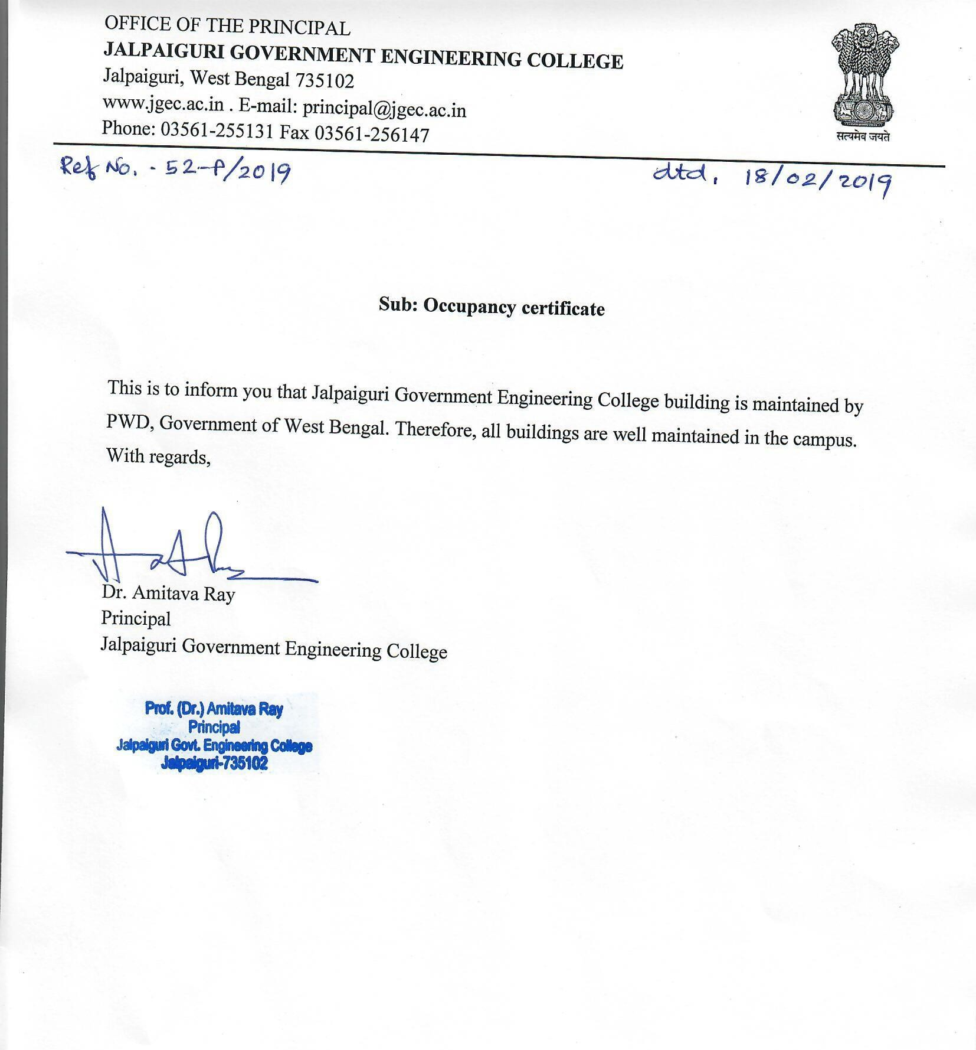

- Fire and Safety Certificate
